PDU of Transport layer is called as a “Segment”, PDU of network layer is called as a “Packet” & PDU of data link layer is called as a “Frame”.

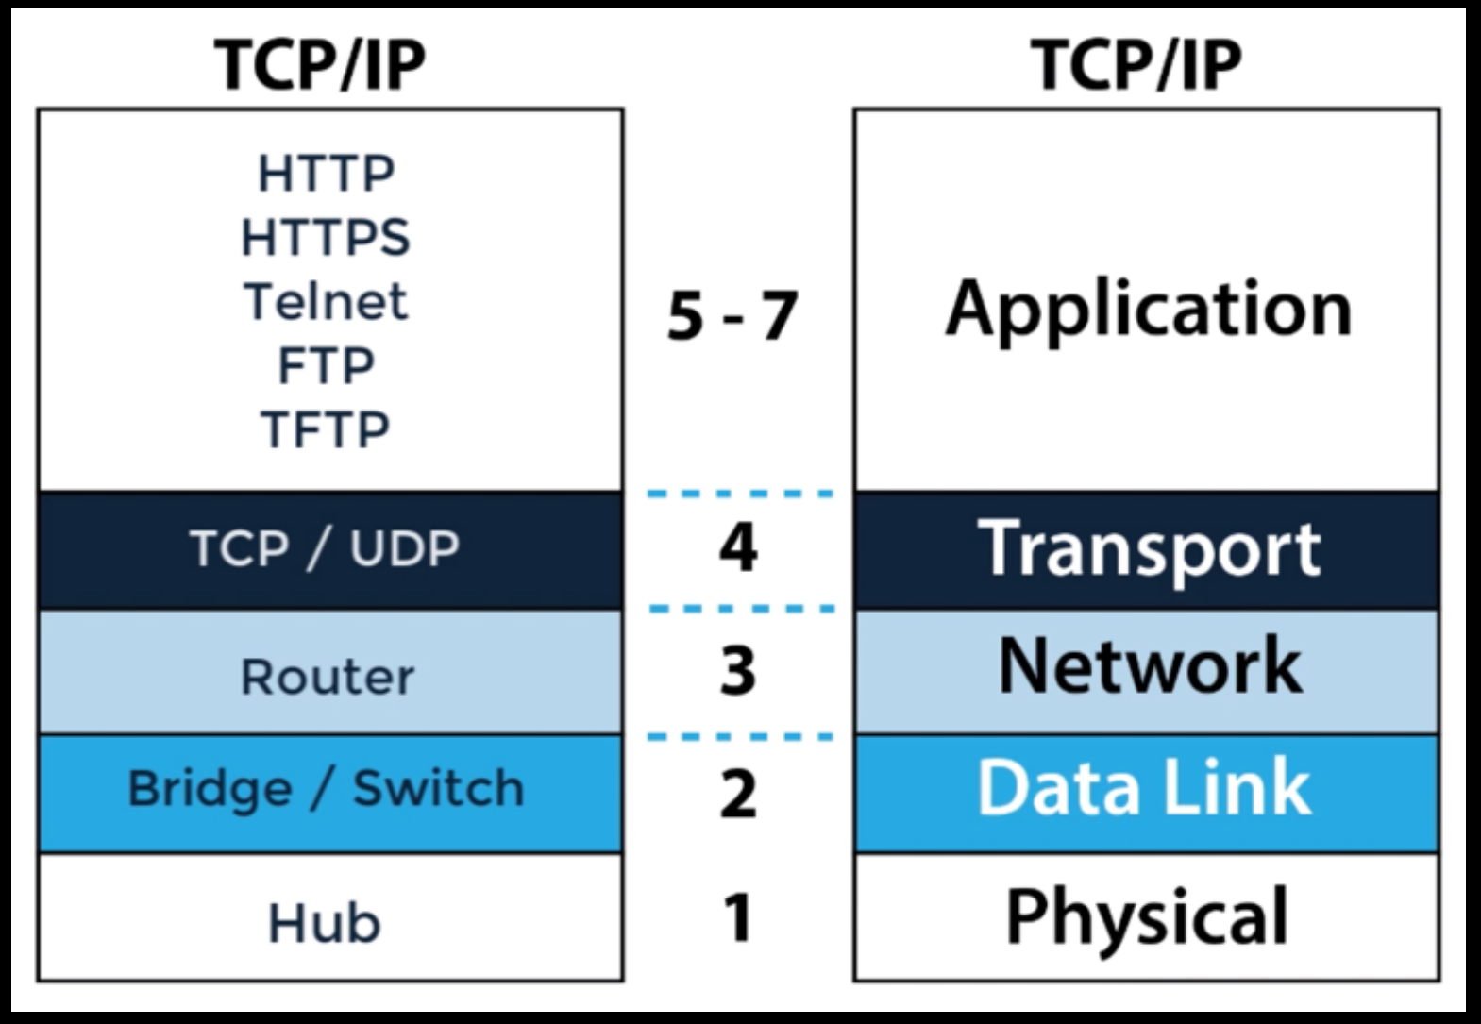

**protocol**

communication **protocol** is a system of rules that allow two or more entities of a communications system to

transmit information via any kind of variation of a physical quantity.

• The protocol defines the rules, syntax, semantics and synchronization of communication and possible error recovery methods.

• Protocols may be implemented by hardware, software, or a combination of both

**port**

a **port** is a communication endpoint.

• At the software level, within an operating system, a port is a logical construct that identifies a specific process or a type of network service.

• A port number is a 16-bit unsigned integer, thus ranging from 0 to 65535

**ephemeral port**

**ephemeral port** - a short-lived transport protocol port for Internet Protocol (IP) communications.

• Ephemeral ports are allocated automatically from a predefined range by the IP stack software.

• An ephemeral port is typically used by the Transmission Control Protocol (TCP), User Datagram Protocol (UDP), as the port assignment for the client end of a client–server communication to a particular port (usually a well-known port) on a server

• The Internet Assigned Numbers Authority (IANA) suggests the range 49152 to 65535 for dynamic or private ports